Introduction
To
GPS Based Vehicle and Person
Tracking System
GPS TRACKING SYSTEM

- INTRODCTION

  - 1.1 WHAT IS GPS TRACKING SYSTEM?

A GPS tracking unit is a device that uses the Global Positioning System to determine the precise location of a vehicle, person, or other asset to which it is attached and to record the position of the asset at regular intervals. The recorded location data can be stored within the tracking unit, or it may be transmitted to a central location data base, or internet-connected computer, using a cellular (GPRS), radio, or satellite modem embedded in the unit. This allows the asset's location to be displayed against a map backdrop either in real-time or when analysing the track later, using customized software.

A GPS tracking system uses the GNSS (Global Navigation Satellite System) network. This network incorporates a range of satellites that use microwave signals which are transmitted to GPS devices to give information on location, vehicle speed, time and direction. So, a GPS tracking system can potentially give both real-time and historic navigation data on any kind of journey.

A GPS tracking system can work in various ways. From a commercial perspective, GPS devices are generally used to record the position of vehicles as they make their journeys. Some systems will store the data within the GPS tracking system itself (known as passive tracking) and some send the information to a centralized database or system via a modem within the GPS system unit on a regular basis (known as active tracking).

- A PASSIVE GPS TRACKING SYSTEM will monitor location and will store its data on journeys based on certain types of events. So, for example, this kind of GPS system may log data such as turning the ignition on or off or opening and closing doors. The data stored on this kind of GPS tracking system is usually stored in internal memory or on a memory card which can then be downloaded to a computer at a later date for analysis. In some cases the data can be sent automatically for wireless download at predetermined points/times or can be requested at specific points during the journey.

- AN ACTIVE GPS TRACKING SYSTEM is also known as a real-time system as this method automatically sends the information on the GPS system to a central computer or system in real-time as it happens. This kind of system is usually a better option for commercial purposes such as fleet tracking and individual vehicle tracking as it allows the company to know exactly where their vehicles are, whether they are on time and whether they are where they are supposed to be during a journey. This is also a useful way of monitoring the behavior of employees as they carry out their work and of streamlining internal processes and procedures for delivery fleets.

  - 1.2 WHAT IS GPS?
The Global Positioning System (GPS) is actually a constellation of 27 Earth-orbiting satellites (24 in operation and three extras in case one fails). The U.S. military developed and implemented this satellite network as a military navigation system, but soon opened it up to everybody else.
Each of these 3,000- to 4,000-pound solar-powered satellites circles the globe at about 12,000 miles (19,300 km), making two complete rotations every day. The orbits are arranged so that at any time, anywhere on Earth, there are at least four satellites "visible" in the sky.

A GPS receiver's job is to locate four or more of these satellites, figure out the distance to each, and use this information to deduce its own location. This operation is based on a simple mathematical principle called trilateration.
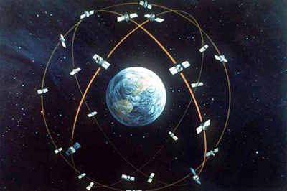
Photo courtesy U.S. Department of Defense
Artist's concept of the GPS satellite constellation

In order to make the simple calculation of the location, then, the GPS receiver has to know two things:
- The location of at least three satellites above you
- The distance between you and each of those satellites
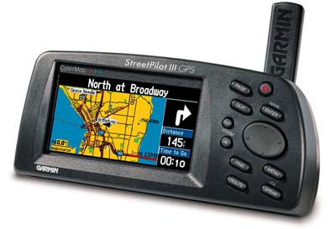
Photo courtesy Garmin
The StreetPilot II, a GPS receiver with built-in maps for drivers

The GPS receiver figures both of these things out by analyzing high-frequency, low-power radio signals from the GPS satellites. Better units have multiple receivers, so they can pick up signals from several satellites simultaneously.

You can use maps stored in the receiver's memory, connect the receiver to a computer that can hold more detailed maps in its memory, or simply buy a detailed map of your area and find your way using the receiver's latitude and longitude readouts. Some receivers let you download detailed maps into memory or supply detailed maps with plug-in map cartridges.

A standard GPS receiver will not only place you on a map at any particular location, but will also trace your path across a map as you move. If you leave your receiver on, it can stay in constant communication with GPS satellites to see how your location is changing. With this information and its built-in clock, the receiver can give you several pieces of valuable information:

- How far you've traveled (odometer)
- How long you've been traveling
- Your current speed (speedometer)
- Your average speed
- A "bread crumb" trail showing you exactly where you have traveled on the map
- The estimated time of arrival at your destination if you maintain your current speed

- 1.3 TYPES OF GPS TRACKING SYSTEM

Three Types of GPS Tracking Units are there.
There are currently three categories of GPS tracking units. The categories are split into how GPS data is logged and retrieved.

- Data Loggers
Data loggers are usually the most basic type of GPS tracking; a GPS data logger simply logs the position of the object at regular intervals and retains it in an internal memory. Usually, GPS loggers have flash memory on board to record data that is logged. The flash memory can then be transferred and accessed using USB or accessed on the device itself. Usually data loggers are devices used for sports and hobby activities. They might include devices that help log location for hikers, bikers and joggers.

- Data Pushers
Data Pushers are GPS tracking units that are mainly used for security purposes. A data pusher GPS tracking unit sends data from the device to a central database at regular intervals, updating location, direction, speed and distance.

Data pushers are common in fleet control to manage trucks and other vehicles. For instance, delivery vehicles can be located instantly and their progress can be tracked. Other uses include the ability to track valuable assets. If valuable goods are being transported or even if they reside in a specific location, they can constantly be monitored to avoid theft.

Data pushers are also common for espionage type tasks. It is extremely easy to watch the movements of an individual or valuable asset. This particular use of GPS tracking has become an important issue in the field of GPS tracking, because of its potential for abuse.

- Data Pullers
The last category of GPS tracking units is the data pusher units. These types of units push data or send data when the unit reach a specific location or at specific intervals. These GPS units are usually always on and constantly monitoring their location. Most, if not all data puller unit also allow data pushing (the ability to query a location and other data from a GPS tracking unit).

- 1.4 FEATURES OF THE GPS TRACKING SYSTEM
Generally all of the GPS Tracking System has some of the common features that are listed below:-

- GSM/Gprs Module - It is used to send the location to the user online. In some case, if the user wants the location through the internet then this module is very useful. By the help of the GSM/GPRS module, we can send data real time. It can be seen on the internet enabled any device as a PC, mobile phone, PDA etc.
- Track Playback - Animates your driver's daily driven route so that you can follow every move. The track animation line is color coded to indicate the speed your driver was traveling during his route.

- Idle Time Report - Gives you an accurate report detailing when your driver was stopped and has left the engine running on the vehicle. This report was designed with input from our existing customers who were concerned about high fuel bills.

- Track Detail - Provides you with a split screen view when reviewing your driver's route. Stop and transit times, as well as speed information, are displayed in the bottom pane. You can easily toggle between stops by clicking the stop number on the track detail pane.
In Figure 1, as the zoom increases, so does map detail. Street names are listed as well as geographic markers (schools, airports, creeks, railways, parks, etc.). At th street level, we can clearly see stops marked by a red stop sign. Clicking on these stops pops up a summary of the stop: stop number, time, location, and duration. This makes it a breeze to determine where and when your employees were at certain locations.
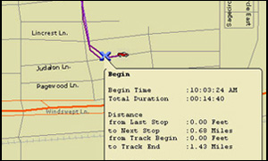
Figure 1

- Speed Bar - Your driver’s route is color coded when it is displayed on the map. The colors represent a 10 MPH or 5 MPH speed range. This allows you to see how fast your driver was driving in a specific area.
In the figure 2, we have an example of a zoom in progress, also notice the speed bar and the color coded route. Determining employee speeds is extremely easy to accomplish.

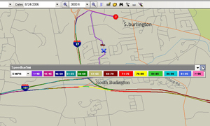
Figure 2

- Mileage By State - Breaks down mileage by state boundaries to assist with DOT reporting.

- Group Reporting - Allows you to set vehicles up into groups for faster and easier reporting.

- Geo Fencing – It allows us ot limit some region of area and if your vehicle go beyond the boundary of that region then urgent message will be sended by the system to the manager to control the driver. So that the time and money can be savec by this system.

- Ignition ON/OFF detection – The system can save the information about the engine that it is in working condition or stop by ignition ON/OFF detection so that the manager can know for how many times the driver stopped the fleet and for how many time. So much time can be saved.

- SMS / GPRS Communication - The location about the fleet or the person can be send by SMS or email by this facility.

- On-Line and Off-Line tracking – Every user has different requirement and as per the requirement the data can be viewed realtime or it can be saved in the unit and when the vehicle reach to its manager, manager can download data and see the route of the vehicle and every other detail that can be seen by the realtime.

- Buzzer for alerting the driver – Some system uses the buzzer system to alert the driver that he is going out of the boundary or the speed is very high,or anything that is restricted. So that the driver is able to know that he is going wrong.

- Monitoring digital events – If you need to know when a piece of machinery was turned On/Off or when a door was Open/Shut, this system will provide you with best options.

- Reports – start stop report, standard report, pto sensor report, aggressive driving report, excessive idling report, vehicle mileage report etc reports can be generated by the system to help understand the driver’s behaviour and to improve it.

- 1.5 DEVICES USED

  - Any mobile device which support GPRS and Bluetooth Connectivity.
  - GPS device
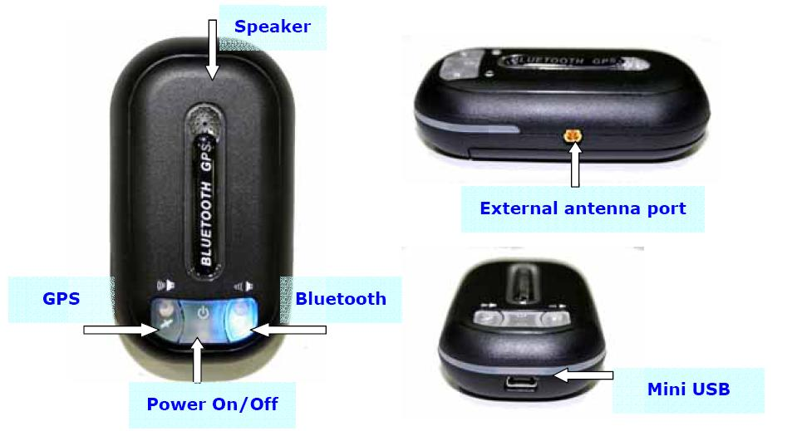
Personal Tracking System

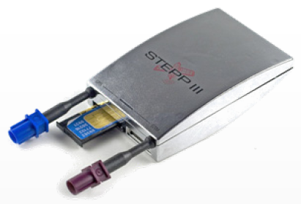
SIM CARD
ANTENNAS
Vehicle Tracking Unit

  - A Computer with the underlying specification:
    - Intel’s Pentium Based Processor. Minimum of 433 MHz. 650 MHz recommended. Above 650 MHz ideal.
    - Minimum of 64 MB RAM recommended. 128 MB ideal.
    - Currently available HARDDRIVE with 80 GB. The system runs efficiently on even 10 GB of HARDDRIVE.
    - Internet connection and required server

      - 1.6 DIFFERENCE BETWEEN TRACKING AND NAVIGATION

A GPS navigation device is any device that receives Global Positioning System (GPS) signals for the purpose of determining the present location. These devices are used in military, commercial aviation, and consumer product applications. Navigation system is sed to guide the person to find his/her route. The GPS navigation device is used to know the exact location of their own that has that device and there is no need to send the information to the other computer or some other person. The device also has an extremely detailed map data and navigation software inside it allowing the user to search for a destination address and point of interest, and then get graphical map instructions supported by voice prompts.
While the GPS tracking system is used for the purpose of tracking the person or vehicle or any other asset and send this information to some authority to know about their assets. The GPS tracking system may or may not have a detailed map data and navigation software inside it allowing the user to search for a destination address and point of interest

- 1.7 DIFFERENCE BETWEEN PERSONAL AND VEHICLE TRACKING SYSTEM
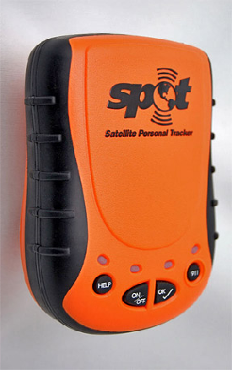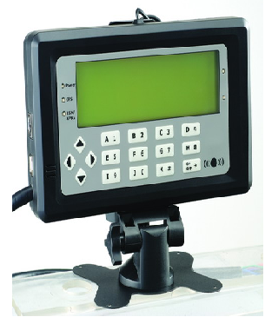
Personal Tracking System Vehicle Tracking System
Personal tracking devices are compact handy device like mobile phone with integrated GPS & GPRS technology and Vehicle Tracking devices are black box type secure devices with ability to work with sensors.

VEHICLE TRACKING SYSTEM is aimed for man who owns a four wheeler and will gain the benefits of real-time location and speed along with the land mark. He can check the details any time through Internet or mobile SMS. He can put a Geo Fence to the vehicle, with which he can put fencing of 200 mts, 500 meters, 1 km etc. The moment the vehicle goes out of this geo fence area he will get an alert on his mobile phone which will help him to understand whether his vehicle is towed away from his residence and if it has been stolen. He can immobilise/stop the vehicle by sending sms and the ignition, fuel and power will be immediately off. After immobilisation his vehicle will not move a single inch. He can inform police and recover his vehicle. He can also take the Over speed alert by putting a cap on the speed as 60 km per hour, the moment driver over speeds he will get a alert in form of sms. This will be useful for large fleet owners to cut their cost by tracking the movement of the drivers. In case a driver is in a problem, he can press the panic button which will send the alert to the owner that the driver is in a problem/emergency. It will be useful for banks which carry large amount of cash.

PERSONAL TRACKING SYSTEM: Parents can put the device in the school bag of the kids and can know where the kid is at any point of time. Kids can press a panic button of the device in case of any problems and phone call will be connected to the parent's mobile and keep on dialing till he picks up the phone. It's useful for corporates for tracking their sales staff. Its useful for military persons as the commander will know the location of his personnel any time when he is at battle field or patrolling, It is also useful for police force to track their staff and officers anytime they want. Application includes :Valuable property, medical facility, electric facility, petro facility, Special professional personnel, such as policemen ,soldiers, prison administrators, security guard, etc. and disadvantaged groups, such as elders, kids, patients, etc., also for outdoor-sports groups ,such as go-abroad, traveling and exploring, etc.

- 1.8 APPLICATION OF THE GPS TRACKING SYSTEM

  - Fleet control. For example, a delivery or taxi company may put such a tracker in every of its vehicles, thus allowing the staff to know if a vehicle is on time or late, or is doing its assigned route. The same applies for armored trucks transporting valuable goods, as it allows to pinpoint the exact site of a possible robbery.
  - Stolen vehicle searching. Owners of expensive cars can put a tracker in it, and "activate" them in case of theft. "Activate" means that a command is issued to the tracker, via SMS or otherwise, and it will start acting as a fleet control device, allowing the user to know where the thieves are.
  - Animal control. When put on a wildlife animal (e.g. in a collar), it allows scientists to study its activities and migration patterns. Vaginal implant transmitters are used to mark the location where pregnant females give birth.[1] Animal tracking collars may also be put on domestic animals, to locate them in case they get lost.
  - Race control. In some sports, such as gliding, participants are required to have a tracker with them. This allows, among other applications, for race officials to know if the participants are cheating, taking unexpected shortcuts or how far apart they are. This use has been featured in the movie "Rat Race", where some millionaires see the position of the racers in a wall map.
  - Espionage/surveillance. When put on a person, or on his personal vehicle, it allows the person monitoring the tracking to know his/her habits. This application is used by private investigators, and also by some parents to track their children.
  - Internet Fun. Some Web 2.0 pioneers have created their own personal web pages that show their position constantly, and in real-time, on a map within their website. These usually use data push from a GPS enabled cell phone.
  - Sport. Sport enthusiast carry it while practising an outdoors sport, e.g. jogging or backpacking. When they return home, they download the data to a computer, to calculate the length and duration of the trip, or to overimpose their paths over a map with the aid of GIS software.
  - Case study:-
- 108 emergency ambulance service:- In India, many of the states have launched the Emergency Management and Research Institute's (EMRI) 108 emergency ambulance service in the state. Gujarat, TamilNadu, Goa, Karnataka, Andhra Pradesh, Uttarakhand, Chennai, Rajasthan and Assam are some of them states which provide the 108 Emergency service. The ambulances would also be equipped with GIS and GPS systems, which would help locate the geographical position of emergency scene and help the nearest ambulance reach the site in the shortest possible time.
The case before the GPS system was not equipped with the ambulances was very different. The manager of the ambulances could not decide which of ambulances to send at the accident site. It might be possible that the manager can order the ambulance to reach at the accident site which is not very near to the site. And there might be a free ambulance near to the accident site. So the manager’s decision was wrong. And it is not tolerable.So they have decided to equip GPS reciever with the ambulances so that the manager can get the location of every ambulances and decide which is nearer to the site.So this is the most advantageous and can save life of thousands
- 911 service through IP or VOIP:- There are many systems for providing 911 services to cellular phones. But these systems are not designed to work in Internet Protocol ("IP") or voice over IP ("VoIP") systems. These systems do not have any way to match a location or address to an IP address because an IP address does not have a physical address or telephone number associated with it. Accordingly, there is a need for an IP based 911.
The present invention provides software applications that communicate with Global Positioning Systems ("GPS") hardware embedded in Internet Protocol ("IP") enabled equipment such that when the equipment is used to access emergency services by entering 911 or pressing an emergency activation button, the software provides the means to determine the location of the calling equipment to the respective emergency service center appropriate to the location of the emergency. More specifically, the software monitors the voice over IP ("VoIP") software installed on the IP enabled equipment. When 911 is entered, the software acquires the vertical and horizontal coordinates ("V&H") from the GPS hardware, overrides the installed VoIP software to send a Session Initiation Protocol ("SIP") request to an address server which is also monitoring the Internet for these specific sessions. The address server accepts the SIP from the originating hardware, receives the V&H and accesses a database that cross references emergency services direct dial numbers with the V&H. The address server passes the voice call and the available direct dial numbers to a call center that handles emergency voice interface with the person who entered 911 at the originating equipment. The call center operator chooses which emergency service to dial after speaking with the person who has the emergency, or defaults to the fire rescue number.
The present invention is applicable to both wireline and IP telephony systems, such as laptop computers, PDAs, etc. The present invention does not rely on a set IP address, so that it will work on virtual networks and with transactional IP addresses. GPS coordinates are cross referenced to the closest physical emergency services. For example, the system may provide four or more numbers to the operator (police, fire, poison control, emergency medical services, rescue, etc.). The operator selects the appropriate number and routes the call via the Public Switched Telephone Network ("PSTN") or directly to the IP address. Note that this invention does not require fixed equipment and is primarily designed for stationary or portable voice or IP enabled devices rather than mobile phones. The present invention completes the IP telephony service.
The present invention provides a method for initiating an emergency IP request using an IP enabled device having GPS capability. The method includes monitoring the IP enabled device for one or more emergency criteria, and obtaining global positioning data using the GPS capability and sending the emergency IP request whenever the one or more emergency criteria are satisfied.

- GPS at Disneyland:- The Rino GPS units have all the features of a high end FRS / GMRS radio so you can talk to each other walkie-talkie style. At first we were worried that with hundreds of people in the park, we would have a hard time finding a free channel. However, the Rino GPS units have 22 channels and 38 squelch codes for a whopping 836 different combinations. We picked a one combination and only once heard another person on our radio during the entire five days we were in the parks. The Rino GPS units are also waterproof, which is a feature that I have yet to see on another FRS radio. You will appreciate not worrying about water when you are on a wet ride like Grizzly River Rapids, or when it starts to rain. They also have a backlight for using at night.
Of course the Rinos also have a built in GPS receiver that can accept downloaded maps. With the StoneMaps “Park Hopper” Disneyland and California Adventure GPS map, we could see exactly where we were as we walked around the parks. The screen is in full color, the resolution is very high, and the images are crisp.
The most amazing feature of the Rino GPS units is the ability to not only see where you are, but also the location of others in your party. Garmin calls this “location polling” and here is how it works. You first set all the radios to the same channel and squelch code at the beginning of the day. Next, you broadcast on Radio 1 by pushing the talk button. All the other radios see that a Rino is broadcasting and each of the other radios ask if you want to add Radio 1 to your list of contacts. You do the same on Radio 2 and so on. Once all the radios are in each list of contacts, then any of the radios can "ping" any other radio and ask it where it is by pushing the page button. You can even give each radio a name and a unique icon. When you look at your map, you can see the name and icon displaying the last known location of that particular radio.

