A

Report

On

GPS Based Track and Trace system

At

Bonrix Software Systems

Prepared by:

Jigar S. Modasia

Parth J. Patel

BONRIX SOFTWARE SYSTEMS
A-801, SAMUDRA COMPLEX,
Nr. KLASSIC GOLD HOTEL,
Off C. G. ROAD,
AHMEDABAD – 380006
GUJARAT (INDIA)
VISIT: www.bonrix.net
mail: info@bonrix.net
Call: +91 79 26426364, +91 94260 45500

Chapter 1

Introduction of GPS tracking system

1.1 Introduction to GPS

The Global Positioning System (GPS) is a Global Navigation Satellite System (GNSS) developed by the United States Department of Defense. It is the only fully functional GNSS in the world. It uses a constellation of between 24 and 32 Medium Earth Orbit satellites that transmit precise microwave signals, which enable GPS receivers to determine their current location, the time, and their velocity. Its official name is NAVSTAR GPS. GPS is often used by civilians as a navigation system.
A GPS receiver calculates its position by precisely timing the signals sent by the GPS satellites high above the Earth. Each satellite continually transmits messages containing the time the message was sent, precise orbital information, and the general system health and rough orbits of all GPS satellites . The receiver measures the transit time of each message and computes the distance to each satellite. Geometric trilateration is used to combine these distances with the location of the satellites to determine the receiver's location. The position is displayed, perhaps with a moving map display or latitude and longitude; elevation information may be included. Many GPS units also show derived information such as direction and speed, calculated from position changes.
GPS consists of three segments - the satellite constellation, ground control network, and user equipment.
Space segment - The satellite constellations that provide the ranging signals and navigation data messages to the user equipment.

Control segment - ground control network which tracks and maintains the satellite constellation by monitoring satellite health and signal integrity and maintaining satellite orbital configuration.

User segment - user equipment.

A visual example of the GPS constellation in motion with the Earth rotating. Notice how the number of satellites in view from a given point on the Earth's surface, in this example at 45°N, changes with time.

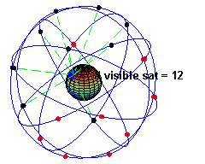

1.2 Introduction to tracking system

A GPS tracking unit is a device that uses the Global Positioning System to determine the precise location of a vehicle, person, or other asset to which it is attached and to record the position of the asset at regular intervals. The recorded location data can be stored within the tracking unit, or it may be transmitted to a central location data base, or internet-connected computer, using a cellular (GPRS), radio, or satellite modem embedded in the unit. This allows the asset's location to be displayed against a map backdrop either in real-time or when analysing the track later, using customized software.
Usually, a GPS tracker will fall into one of these three categories:
Data Loggers:-
A GPS logger simply logs the position of the device at regular intervals in its internal memory. Modern GPS loggers have either a memory card slot, or internal flash memory and a USB port. Some act as a USB flash drive. This allows downloading of the data for further analysis in a computer. i.e. Sports persons, gliding etc…

Data pushers:- This is the kind of devices used by the security industry, which pushes (i.e. "sends") the position of the device, at regular intervals, to a determined server, that can instantly analyze the data. i.e. Fleet control, Stolen Vehicle control, Race control etc.

Data pullers:- Contrary to a data pusher, that sends the position of the device at regular intervals (push technology), these devices are always-on and can be queried as often as required (pull technology). This technology is not in widespread use, but an example of this kind of device is a computer connected to the Internet and running gpsd. Data Pullers are coming into more common usage in the form of devices containing a GPS receiver and a cell phone which, when sent a special SMS message reply to the message with their location.

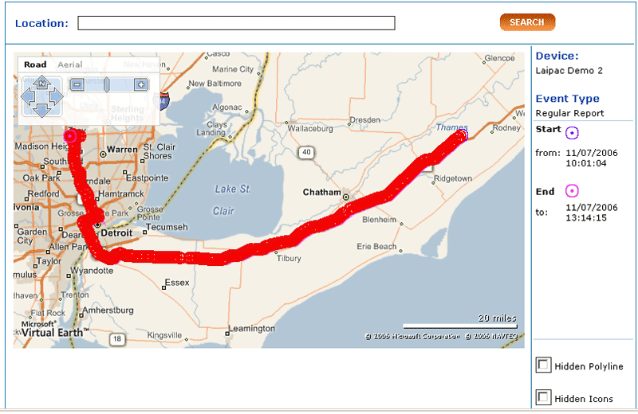

[The traced path of a tracking device ]

Chapter 2

Types of tracking system

2.1 Vehicle tracking system
A vehicle tracking system is an electronic device installed in a vehicle to enable the owner or a third party to track the vehicle's location. Most modern vehicle tracking systems use Global Positioning System (GPS) modules for accurate location of the vehicle. Many systems also combine a communications component such as cellular or satellite transmitters to communicate the vehicle’s location to a remote user. Vehicle information can be viewed on electronic maps via the Internet or specialized software.

It is commercially very useful and broadly use. The GPS satellite system was built and is maintained by government and is available at no cost to civilians. This makes this technology very inexpensive.
Several types of Vehicle Tracking devices exist.
Typically they are classified as "Passive" and "Active".
Passive devices store GPS location, speed, heading and sometimes a trigger event such as key on/off, door open/closed. Once the vehicle returns to a predetermined point, the device is removed and the data downloaded to a computer for evaluation. Passive systems include auto download type that transfer data via wireless download.
Active devices also collect the same information but usually transmit the data in real-time via cellular or satellite networks to a computer or data center for evaluation.

Basically the major market for the vehicle tracking system are Stolen Vehicle Recovery,Fleet management, Asset Tracking,Field Service Management etc.

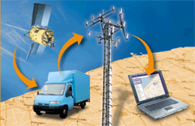

[The basic format in which the whole data is passed on in the vehicle tracking system]

2.2 Personal Tracking System

Personal Tracking System are the tracking devices but specially built up for personal information. The person takes it with him and the information of where he is presently is provided, it also give the information about where the person has been throughout the day. This information is sent by the device to the control server using GPS/GPRS services which controls and monitors all the devices. From this database the owner can locate where the device and the related persona are situated. Specially used by parents to keep track of the activities of their children. Many of these devices act as phones having special numbers which can be used to call in times of emergency. They might also have video display.

PARENTS can put the device in the school bag of the kids and can know where the kid is at any point of time. Kids can press a panic button of the device in case of any problems and phone call will be connected to the parent's mobile and keep on dialing till he picks up the phone. It's useful for CORPORATES for tracking their sales staff. Its useful for military persons as the commander will know the location of his personnel any time when he is at battle field or patrolling, It is also useful for police force to track their staff and officers anytime they want.

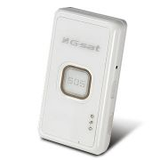

[GPS/GSM/GPRS Personal Tracker with Voice Monitor Function ]

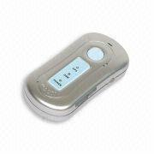

[Personal Tracker with GPS Tracker, Finds Location through Free Google or Other Software Maps]

Chapter 3

Navigation System

3.1 Introduction

An automotive navigation system is a satellite navigation system designed for use in automobiles. It typically uses a GPS navigation device to acquire position data to locate the user on a road in the unit's map database. Using the road database, the unit can give directions to other locations along roads also in its database. Dead reckoning using distance data from sensors attached to the drivetrain, a gyroscope and an accelerometer can be used for greater reliability, as GPS signal loss and/or multipath can occur due to urban canyons or tunnels.

Whenever we are visiting a new place or seem lost at a particular place this system comes to our help. We just need to connect via the device and just specify our destination. The device works according to the GPS and finds our location and then it matches our location with the road map database or the relevant database. Once done and its comes to a solution for the path the user must follow it sends the signal back to the user, specifying the directions the user must follow to get to its destination. While doing this it also continuously keeps track of the position of the user to check whether he/she is moving towards the target or away from it. Commercial navigation software is widely available for most current smartphones as well as some Java-enabled phones that allows them to use an internal or external GPS receiver (in the latter case, connecting via serial or Bluetooth). Phones with this capability function no differently to a dedicated portable GPS receiver and may even use the same software.

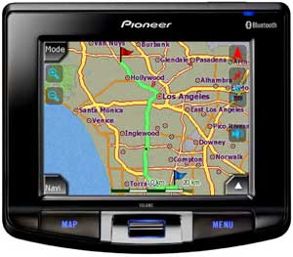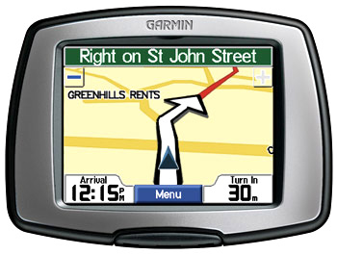

These are examples of how the user sees the maps and gets the direction towards his/her destination.

Chapter 4

Features of Tracking System

- Targeted Event Generation: Many devices on the market are designed simply to transmit copious amount of GPS data to a back-end server hoping that the server can make sense of the data that it is receiving. The problem with this approach is that it tends to result in higher data transmission costs for information which will never be used. A protocol used for mobile applications need to be able to provide the flexibility to generate only the events that are pertinent to the specific application.

- Network Efficient: Mobile devices typically have limited network connectivity, and in some cases data communication can be quite expensive (e.g. satellite). Because of this the protocol needs to be efficient in it's dialog between the client and server. The communication needs to be optimized such that the necessary information can be conveyed with a minimum number of bytes in the least amount of time.

- Transport Media: Different mobile applications will have their own unique way of communicating data back to the server. Some may use GPRS, or socket based communication, others may use satellite communication, while still others may use other forms of wireless communication, such as BlueTooth. The design of the protocol should be able to encompass all such transport media types, regardless of the type of transport in use.

- Bi-directional: Some devices can support two-way communication (I.e. GPRS, or other socket based connections), while others may only support one-way communication (i.e. some satellite communication systems). With this in mind, a protocol should be designed to support both duplex (two-way) and simplex (one-way) communication.

- Flexible Data Encoding: Most types of transport media allow for the transmission of binary encoded data. However, there may be some forms of media for which an ASCII encoded data packet is much better suited. A protocol designed with this in mind should be able to support both types of data encoding.
- Configurable Messages: Due to the broad range of data types used in mobile applications, the protocol should be flexible enough to define standard messages, yet still allow custom messages within the framework.

- Extensible: Not every mobile application is the same. Some require special handling and may have various types of inputs and outputs. A protocol designed for mobile applications should insure that the framework can be easily extended to encapsulate the specific needs of the device.

- Small Footprint: Mobile devices typically have limited resources on which to run client code (ie. memory, processor speed). An open protocol designed with this in mind should be optimized to allow efficient implementation and should easily support devices such as PDA's, mobile phones, GPS monitoring devices, and other OEM micro-devices.

- Industry Compatibility: Having an open protocol insures better compatibility between different client devices and service providers.

- Reference Implementation: Having a reference implementation that showcases the major features of the protocol provides an easy starting point on which developers can add their own features and platform specific implementation without having to worry about how data gets from the client to the server. The supported reference implementation platforms include Embedded Linux, Windows CE/Mobile, and Java.

- Web-based authentication: Each account can support multiple users, and each user has its own login password and controlled access to sections within the account.

- Customizable web-page decorations: The look and feel of the tracking web site can easily be customized to fit the motif of the specific company.

- Customizable mapping service: comes with support for Mapstraction in addition to the original support for Google Maps and Microsoft Virtual Earth. With the addition of Mapstraction can display maps from OpenLayers, MultiMap, Map24, MapQuest, and more. Within the framework, other mapping service providers can also easily be integrated with minimal effort.

- Customizable reports: Detail and summary reports can be customized to show historical data from a specific vehicle, or from the fleet.

- Customizable geofenced areas: Custom geofenced areas (geozones) can be set up to provide arrival/departure notification. Each geozone can also be named to provide a custom 'address' which is displayed on reports when inside the geozone.

- GPS tracking device independent: comes with support for OpenDMTP capable devices, but also can easily be integrated to work with nearly any available remote GPS tracking device. This allows using a single web interface to track differing remote hardware types.

- Operating system independent: written in Java, using technologies such as Apache Tomcat for web service deployment, and MySQL for the datastore. As such, It is only limited to operating environments on which Java and MySQL will run.

- Language Flexibility is compliant and supports easy localization (L10N) to languages other than English.

- Event notification: Advanced "Rules-based" event notification based on predetermined criteria from received events. For instance, an email could be sent if a vehicle is outside a geofenced area on a weekend.

- Stateline border crossing: Ability to record and report state-line border crossings for fuel tax purposes.
Chapter 5

Applications Of GPS based Tracking system

Fleet Control
For example, a delivery or taxi company may put such a tracker in every of its vehicles, thus allowing the staff to know if a vehicle is on time or late, or is doing its assigned route. The same applies for armored trucks transporting valuable goods, as it allows to pinpoint the exact site of a possible robbery.

Stolen Vehicle Searching
Owners of expensive cars can put a tracker in it, and "activate" them in case of theft. "Activate" means that a command is issued to the tracker, via SMS or otherwise, and it will start acting as a fleet control device, allowing the user to know where the thieves are.

Animal Control
When put on a wildlife animal (e.g. in a collar), it allows scientists to study its activities and migration patterns. Vaginal implant transmitters are used to mark the location where pregnant females give birth.[1] Animal tracking collars may also be put on domestic animals, to locate them in case they get lost.

Race Control
In some sports, such as gliding, participants are required to have a tracker with them. This allows, among other applications, for race officials to know if the participants are cheating, taking unexpected shortcuts or how far apart they are. This use has been featured in the movie "Rat Race", where some millionaires see the position of the racers in a wall map.

Espionage/Surveillance
When put on a person, or on his personal vehicle, it allows the person monitoring the tracking to know his/her habits. This application is used by private investigators, and also by some parents to track their children.

Internet Fun
Some Web 2.0 pioneers have created their own personal web pages that show their position constantly, and in real-time, on a map within their website. These usually use data push from a GPS enabled cell phone.

Sport
Sport enthusiast carry it while practising an outdoors sport, e.g. jogging or backpacking. When they return home, they download the data to a computer, to calculate the length and duration of the trip, or to overimpose their paths over a map with the aid of GIS software.
Chapter 6
Case Studies

6.1 Delhi Transport Corporation

Delhi Transport Corporation is the one of the largest City Road Transport
Undertaking in the India. It has a fleet of around 15,000 vehicles carrying on
the business of passenger transport on 800 routes from 33 depots all over the
state of Delhi with a product mix comprising of City and Inter-city services.
CMC has Designed, Developed and Implemented the Automatic Fleet
Management System that include Vehicle Tracking System, Application software for billing, Operational Transportation Model for scheduling of buses and integration of Smart Card Reader with the Vehicle Tracking System, provision for Real Time Passenger Information System to Delhi Transport Corporation. The AFMS system is currently operational from two depots for 200 buses since last two years.

Objectives

• Integration of GPS with GIS map of Delhi for tracking of vehicles on a real
time basis with two way messaging including distress messaging between the vehicle and the control station

• To monitor whether the buses are adhering to its scheduled route and time
table through out the route and identify if there are any deviations.

• To monitor whether the buses are giving halt at all the scheduled bus stops
especially of KMs operators, which is resulting in loss of revenue.

• Automatic generation, collection, storage and retrieval and analysis of data & information and thus eliminating the human related errors involved in
collecting of such data.

• Development of custom on-line queries for DTC related to GIS

• Integration with the database of DTC pertaining to employees, buses, bus
stages, fare stages, depots, school bus routes & stages

• Used as a decision support system for implementation of Transport Model by DTC

• Generation of exception reports like deviation from schedule route, timing,
Missing Bus stops, Punctuality factor etc. based on captured vehicle data.

• Provide billing software to generate automatically billing details for the buses.

• Dispatching of emergency vehicles to Breakdown vehicles or vehicles in
distress, whenever it is sought.

• Provision for integrating Smart Card Readers being supplied by Delhi Metro
Rail Corporation.

• Help in working out realistic schedules according to traffic conditions based
on speed of bus during different hours of the day and at different segments

• Provision for Real Time Passenger Information System – both within the bus as well at major Terminuses.

• To accomplish the above-mentioned objectives, CMC Ltd has developed an
Automatic Fleet Management System incorporating its DGPS based Automatic Vehicle Tracking and Management system (AVTMS), Nirdeshak and customising the same.

Salient System Features

• GPS based Nirdeshak Unit mounted on 200 buses belonging to 2 depots

• Monitoring from a Central Control Station, 2 depots simultaneously

• Solaris based Database Server, AVTMS server, Communication Server

• Display of vehicles at Workstation using ARC Info suite and VC++ based
application software

• Real Time two way messaging between buses & CCS

• Public Mobile Radio Trucking System (Wireless Communication network) for collecting data from buses. Area of coverage is 1500 square kms.

• The salient features of GIS related activities in this project include Verification and Validation of GIS data of Delhi procured from a GIS
data vendor, with the help of GPS in both standalone and differential
mode. This is to ensure that the data is in required co-ordinate system.

• Field trails were conducted with buses mounted with VMUs (Vehicle
Mounted Units) to ensure the integrity of the GIS data of Delhi.

• Additional custom data as required in this project like bus stops
information where DTC operates, Landmarks (both Geographical
position and corresponding attributes), school routes and
corresponding turn information (lane connectivity information) etc.,
were collected by conducting extensive DGPS based field survey and
was geo-coded on the GIS map of Delhi. Geographical position
surveyed by National Geophysical Research Institute, Hyderabad at
DTC, I.P. Depot, is used as DGPS reference station for conducting field
surveys.

• GIS data is integrated with the turntables containing turning
information at various junctions along with one way, two ways etc.

• Application development and customization of screens, forms, reports
and queries of GIS data specifically includes:

– Locating a particular bus in the fleet
– Auto pan facility for tracking a particular bus
– Sending online messages to an individual bus or group of buses selected on a GIS map
– Creating and editing No entry and No exit zones
– Zone violation reports for both no entry and no exit zones
– Different Icons were provided for different distress messages
like fire, CNG leakage etc., from various buses on the GIS map
at the control station, online. For e.g. If a bus in the fleet sends
a fire message, bus under fire Icon will be generated and
flashed on the GIS map

– Finding out the shortest and fastest path to the bus in distress
on the GIS map and generating the directions of that path for
sending relief vehicle

– Generating messages pertaining to speed violation, skipping bus
stops etc., to DTC officials at the Central Control Station (CCS),
online along with the Geo-graphical position and the violated
vehicle number through trunk radio network

– Creating and / or modifying daily duty slips, which are provided
to the drivers prior to the commencement of his shift, by
selecting the bus from the GIS map. These slips consist of
information pertaining to the route(s) and schedules to be
operated on a particular day. This information will be
downloaded to the VMU (Vehicle Mounted Unit) over the radio
network before the bus leaves the depot.

– Calculation of the actual distance (in Kilometres) travelled by the vehicle, using the GIS map.

6.2 Supply Chain Management

Exel UK Ltd. is the world leader in supply chain management, providing customer-focused solutions to a wide range of industries including retail, consumer technology, automotive, healthcare, chemical and industrial. Exel’s innovative supply chain solutions, skilled people and regional coverage, bring together all aspects of freight management and contract logistics in addition to a wide range of integrated, value-added and specialist services.

In March 2004, one of the major customers to Exel, implemented a Track and Trace project to improve the efficiencies of its logistics chain. The ultimate goal was to provide first class service for the large wholesale and retail customers, which would allow them access to the order status details real-time. At this initiative, Exel, the third party logistics and transportation service provider coordinating haulage for a market leader in nearly a dozen major consumer products categories products, began the search for suitable software and hardware solutions available in the marketplace. Exel had been using a paper-based system for route scheduling and proof-of-delivery. They searched for an electronic solution that would provide the drivers instant access to order information and job schedules, and also capture signatures on the electronic proof-of-delivery form. Supply chain process and system specialist 3Peaks Solutions Ltd. was selected to design and develop a system called Track and Trace, which would connect the drivers to the central order management database and also include electronic forms - such as the proof-of-delivery document. It was determined that the hardware solution should be a user-friendly, portable, ruggedized system, with wireless data transfer capabilities, to facilitate communications between the vehicles and the company’s central systems. As soon as the software was outlined, the display size and the method of input became critical factors for hardware selection.

Xplore’s strategic business partner Psion Teklogix, who is a global provider of mobile computing solutions, introduced the iX104C2 Tablet series for Exel and other companies involved in the project. Xplore’s iX104C2D Tablet PC’s, with integrated GPRS and snap-on GPS module, were selected as the hardware to run the Track and Trace software. “A very important factor that influenced our decision for the Xplore tablet is the size of the screen. It enables both the drivers and customers to view more information, when they are on-line reading the dispatch note. We also like the element of the dual mode screen, as the drivers often prefer to use the touch screen”, states David Williams, Systems & Process Manager at Exel UK Ltd. and continues: “The proof-of-delivery document printed off at the warehouse is an A4 sheet size. The screen size of the Xplore tablet is approximately the size of the A4 sheet. We can enter all the information from the paper proof-of-delivery onto the screen of the tablet. As far as a customer is concerned, the driver, rather than arriving with a sheet of A4 paper, has all the same data on the tablet. The customer does not really see a huge amount of change at their end. It’s just an A4 size paper on electronic equipment they can read or sign. So the cultural adjustment for the customer is fairly minor, but they get all the benefits.”
The Track and Trace system developed by 3Peaks Solutions is easy-to-use software ideal for the dual mode display technology on Xplore iX104C2D tablets. The drivers often use the resistive touch screen with finger input to click the icons, but the stylus and digital ink is needed for signatures. Richard Knight from 3Peaks explains: “From the design elements, we made the software as simple to use for drivers as possible. The software is icon-based, which the drivers can touch in order to move to the next step.”
The Xplore tablets are not mounted in a vehicle; but the tablet, the USB scanner and the power charger are kept in a portable briefcase. When the drivers deliver stock to the customers, they utilize the tablets to view the deliveries and dispatch notes. When the driver arrives at the customer site, he is able to use the software on the tablet to update all the delivery details, such as actual merchandise delivered, and then send the information back to the central systems via GPRS. The company, as well as its customers, have precise delivery data and can compare it to the customers’ order. At the customer’s site, the driver can take the unit out to the receiving deck. The customer can then view their order on the tablet and check that it was delivered complete. If there are any discrepancies in the delivery, he can enter them on the form in the tablet before signing off the delivery. The completed order is updated real-time to the company’s on-line system, where the customer can visually track the status of their order. This also allows the company’s other locations, e.g. a corporate office that may be located elsewhere in the country, to review the status of the order real-time, rather than wait for proof-of-delivery paper sheets to go through their internal systems. This customer-friendly approach still offers a choice of paper proof-of-delivery. A USB scanner is connected to the tablet and the driver can scan any paper notes for customers who prefer to have a paper document.

Another crucial element in the solution is the collection of positioning data. “We use GPS satellite navigation to collect coordinates on the driver’s location, so that we have accurate confirmation of his delivery coordinates. An important factor of this whole project was the ability to measure the accuracy of deliveries. When the driver arrives at the customer site, he uses the icon on the Xplore tablet to record the arrival in the system. The GPS and location data confirms the driver is actually on site at the customer location. Secondly, through the GPS, the Track and Trace system allocates the time when delivery schedules are made”, David Williams explains.

The Track and Trace system offers multiple benefits. The data is accurate, as electronic data input eliminates the margin for error that is common with paper-based systems. Customers have access to up-to-date information on-line regarding the status of their orders and can adjust their operations accordingly. The office personnel receive information on completed deliveries real-time and can invoice the customer instantly based on the customer’s confirmed receipt. Also, deliveries are monitored based on the accurate location data of the trucks provided by satellite coordinates and GPS.

